 | Search and View Submitted Marriage Records |  | OMRS-006
- From the Home page click on the Search Marriages button located at the left side menu  Note: You can search marriage records you have submitted to Births, Deaths and Marriages. You can search party name/s and date of marriage. You cannot make changes to the marriage record.  - Enter the Party 1 Surname and/or Party 2 Surname  Note: When searching by Party 1 and Party 2 surnames it will not matter if you enter the surnames in the opposite fields. The search will still locate a marriage with those surnames if it exists.  - If you know the exact date of marriage select Yes  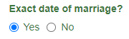  - Enter the date of marriage  - If you do not know the date of marriage select No  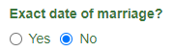 |  | - Enter the date range of the marriage  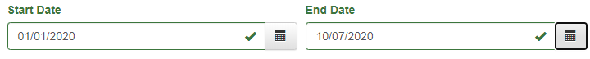  - Click on Search  - The results will appear in a table below  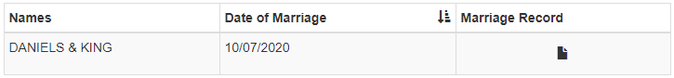  - Click on the Marriage Record icon  - The marriage record will open for viewing  - Click on Search Marriages button located at the left side menu to be taken back to your search results  - Click on Clear Search to start again

