 | Submit Marriage Record |  | OMRS-004
Before submitting the marriage record to Births, Deaths and Marriages you will need to scan and save copies of the signed NOIM, Certificate of Marriage and Declaration of No Legal Impediment to Marriage to your personal device.  You will need to upload these files when you submit the marriage to be registered.  Each file must not be larger than 10MB and must be one of the following types: bmp, jpeg/jpg, tiff/tif, png, doc/docx, or pdf.  - From the Home page select the marriage you want to submit for registration by clicking on the Submit icon in the Submit column  Note: if there is no Submit icon available there are fields for that marriage record that have not been completed. You will need to click on the Marriage Record icon. Section headers that appear in red have fields that are incomplete.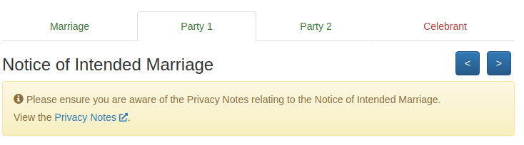  - Choose whether you would like to order a certificate by clicking on the Yes or No button  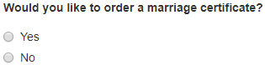  Note: refer to quick reference guide ‘Order Marriage Certificate Online’  - Attach the NOIM, Certificate of Marriage and Declaration of No Legal Impediment to Marriage by clicking on the Browse 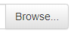buttons  - Go to where the file is saved on your personal device and attach the NOIM, Certificate of Marriage and Declaration of No Legal Impediment to Marriage  Note: If you have attached the incorrect file you can simply click on the Browse button again and select the correct file to replace the incorrect attachment |  | Note: if you have additional files to upload e.g. a Certificate of faithful performance of interpreter or Consent of Judge or Magistrate to under age marriage repeat step 4  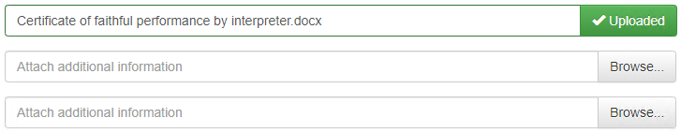  - Please read all the information on the page before you click on the I Agree checkbox  - Click on the Submit button  - The following screen appears  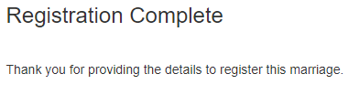  - A confirmation email is sent on submission of the marriage record to BDM  