 | Print NOIM or Official Certificate of Marriage | OMRS-003
- From the Home page click on the Marriage Record icon next to the relevant marriage (when you are ready to print the NOIM, and No Legal Impediment to Marriage)
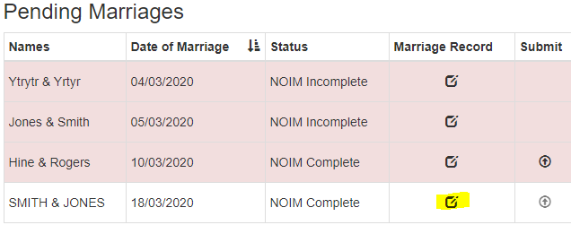
- Click on the Print NOIM or Print Marriage Certificate button from the side menu
- The documents will open as a PDF in your web browser. Details you have entered into the marriage record so far will appear in the document
- Go to the top right hand corner of the screen and click on the Print icon
- The print options screen will appear. If you are happy with the printer settings on your machine you can click the Print button

