 | Create New Marriage Record |  | OMRS-002
- To create a new marriage record click on the New icon  - Fill in Marriage Details  Note: You can click on the Save icon and leave the record at any time after you have entered the surnames of both parties and the date of marriage  - Click on the Save icon  Note: You can leave fields such as witness names blank to fill in later. At this point you may not have all the information needed but you can print a NOIM at any time. You can continue to fill in the printed NOIM or reprint the NOIM as long as the submitted NOIM is complete with all signatures.  - Click on the Continue button or Party 1 tab at top of page when you are ready to enter Party 1 details  - Fill in Details of Party 1  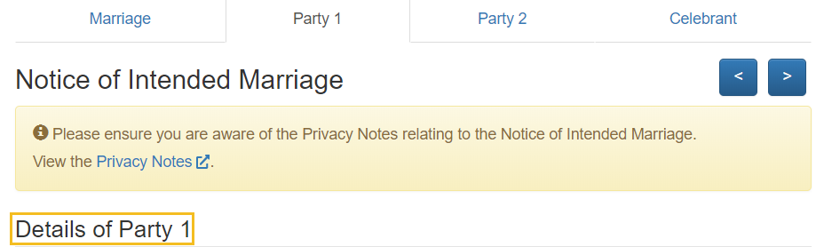  Note: If either Party 1 or Party 2 was born overseas their total period of residency in Australia can be entered as below with years plus months or only months (only months example below)  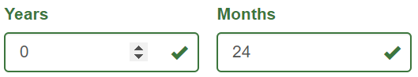  - Click on the Continue button  - Fill in Party 1 – Previous Marriages details  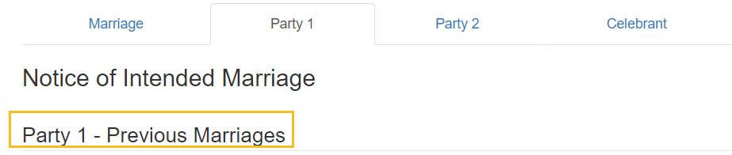  - Click on the Continue button or Party 2 tab at top of page when you are ready to enter Party 2 details |  | - Fill in Details of Party 2  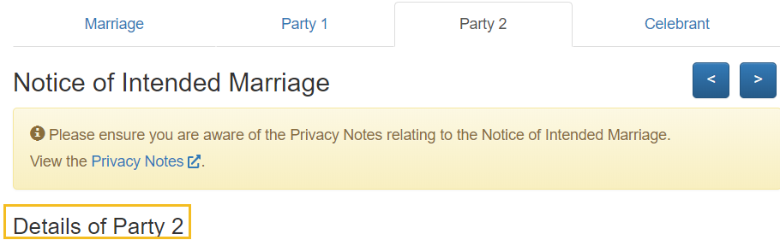  - Click on the Continue button  - Fill in Party 2 – Previous Marriages details  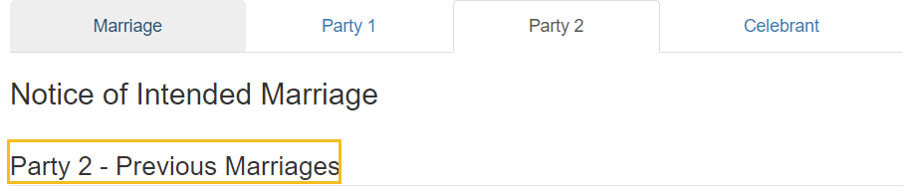  - Click on the Continue button or Celebrant tab at top of page when you are ready to enter the Particulars to be completed by Authorised Celebrant  - Confirm additional details required on NOIM e.g. date NOIM received and evidence of ID sighted  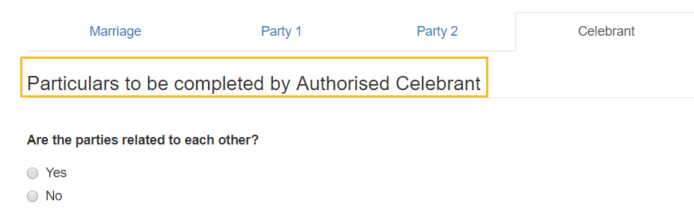  Note: Fields you have left blank will appear in red. You can still save the record but all fields must be completed before submitting  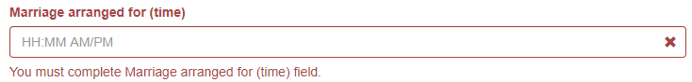  - Click on the Print NOIM button if you are ready for the couple to sign the NOIM  - Click the Save button.

