Reset a Forgotten Password |  | OMRS-007
- At the Login page click on Forgot your password?  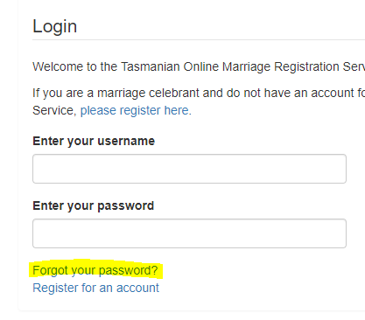  - Enter your email address that you use to login to the Online Marriage Registration Service and click on the Reset Password button  - The following message will appear -  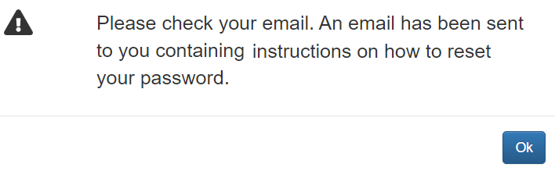  - The email sent to you will provide you with a temporary password  - Return to the login page and enter your username and temporary password  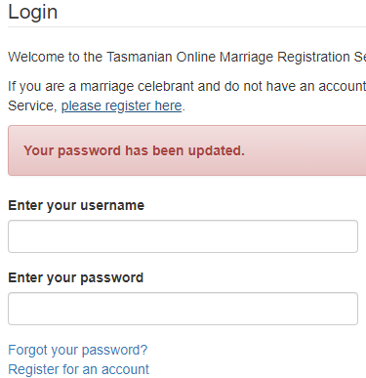 | - Enter your new password, remember your new password must contain at least one symbol or punctuation character  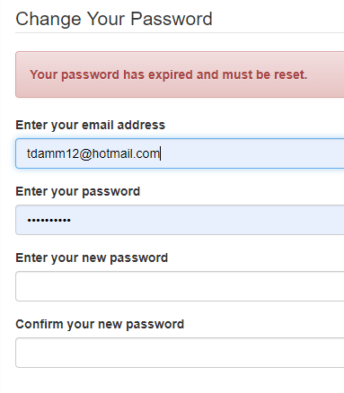  - Your password has been updated  