 | Order a Marriage Certificate |  | OMRS-005
If you wish to order a marriage certificate for the couple, you must do it at the same time as submitting the registration information.  - If you selected Yes to ordering a marriage certificate the following screen will be displayed once you have submitted the marriage record  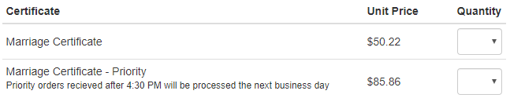  - Choose between the two available products -  - Marriage Certificate - sent in about 7-10 working days  - Marriage Certificate Priority – sent the same day or following day  - Select the quantity you would like and click on the Next button  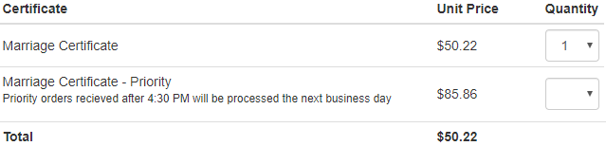  - You will need to confirm the delivery address. You will have the option of selecting the recipient as Party 1 or Party 2 which will populate the fields from the marriage record already recorded. Selecting Other will require you to manually enter the recipient residence fields  - For postal address selecting Yes will copy the fields from the residence address fields. Selecting No you will need to manually enter the postal address fields  - Click on the Next button  - Click on the Register Marriage button  - Registration is now complete – to pay for the marriage certificate click on the Next button  - Read the terms and conditions and then click on the I Agree checkbox |  | - Click on the Pay Now button  - You will be taken to the Westpac online payment service  - Enter the Visa or Mastercard details and click the Next button  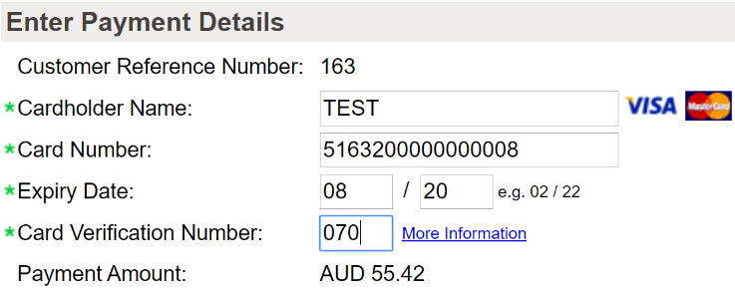  - Enter the security check number  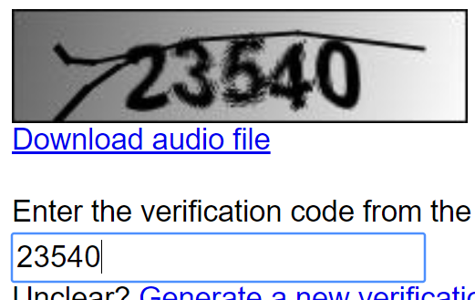  - Click on the Confirm Payment button  - Your receipt will be displayed

